# SPEED TYPING TEST

**1.Abstract:**

In this python project, our goal is to build a game in which user can check and even improve typing speed. A typing speed test help us to check our typing speed and improve it with regular practice. The project contains only the users side. It is a simple typing challenge game project. This is like a game, one-by-one random word will pop up on your screen and you have to type as many given words as you can. The design of this project is pretty simple so that the user won’t find any difficulties while working on it…

**2.INTRODUCTION:**

* A speed typing test is a tool designed to assess an individual's typing proficiency and speed.
* It serves as a practical method for evaluating how quickly and accurately someone can input text on a keyboard.
* These tests are commonly used for various purposes.
* The primary goal of a speed typing test is to measure the number of words or characters a person can type within a specified time frame, usually measured in words per minute (WPM) .
* The test typically involves typing a given word, and the accuracy and speed of the typist are calculated based on the completed text.

**The Importance of Speed Typing Test:**

The speed typing test holds significant importance in various contexts, reflecting its relevance in today's technology-driven world. Here are some key reasons why speed typing tests are considered valuable:

**1.Work Efficiency and Productivity:**

In professional settings, particularly jobs that involve extensive computer use, such as data entry, content creation, and coding, efficient typing skills can significantly enhance productivity.

Faster typing allows individuals to complete tasks more quickly, contributing to overall workflow efficiency.

**2.Employment Assessments:**

Many employers use speed typing tests as part of their hiring process to assess the typing skills of candidates applying for positions that require computer proficiency.

These tests help employers identify individuals who can handle the demands of roles involving substantial keyboard use.

**3.Time Management:**

Efficient typing reduces the time needed to compose emails, documents, and other forms of communication.

Individuals with good typing skills can manage their time more effectively, allowing them to focus on other aspects of their work.

**4.Accuracy in Communication:**

Speed typing tests often include an accuracy component, ensuring that individuals not only type quickly but also maintain a high level of accuracy.

Accurate typing is crucial in professional communication to avoid errors and misunderstandings.

**5.Educational Assessements:**

In educational settings, speed typing tests may be used to assess students' computer literacy and typing proficiency.

Educational institutions may incorporate these tests to prepare students for future academic and professional requirements.

**6.Self-Improvement:**

Speed typing tests serve as valuable tools for individuals looking to enhance their typing skills.

Regular practice with these tests can contribute to the development of muscle memory, leading to improved typing speed and accuracy.

**7.Technology Adaptation:**

As technology continues to advance, proficiency in typing becomes increasingly essential.

Speed typing tests help individuals adapt to evolving technological demands, ensuring they can navigate digital environments efficiently.

**8. Competitive Advantage:**

In competitive job markets, possessing strong typing skills can be a differentiator.

Individuals with faster and more accurate typing abilities may have a competitive edge over others in securing certain positions.

**3.Key Features of the Application:**

Speed typing tests can vary in features depending on the platform or software used, but here are some key features commonly found in speed typing tests:

**1.Word/Character Count:**

Provides the number of words or characters typed within a specific time frame, often measured in words per minute (WPM) or characters per minute (CPM).

**2.Accuracy Measurement:**

Evaluates the accuracy of typing by tracking and calculating errors. Accuracy is usually expressed as a percentage**.**

**3.Timed Sessions:**

Sets a specific time limit for the typing test, commonly ranging from one to five minutes. This feature helps measure typing speed under time constraints.

**4.Text Samples:**

Offers a variety of text samples for users to type, ranging from simple sentences to more complex paragraphs. Some tests may allow users to choose the difficulty level.

**5.Randomized Content:**

Randomizes text passages to prevent memorization and encourage adaptation to different writing styles and structures.

**6.Real-time Feedback:**

Provides immediate feedback on typing speed and accuracy, often displaying results at the end of each session.

**7.Error Highlighting:**

Highlights errors made during typing, allowing users to identify and correct mistakes efficiently.

**8.Training Modes:**

Includes training modes or drills designed to help users practice specific keys or key combinations to improve overall typing skills.

**9.Platform Accessibility:**

Provides flexibility in accessing the speed typing test, whether through online platforms, desktop applications.

**4.HARDWARE & SOFTWARE REQUIREMENTS:**

**4.1 HARD REQUIRMENTS :**

* System    :   Pentium IV 2.4 GHz.
* Hard Disk  :   40 GB.
* Floppy Drive :   1.44 Mb.
* Monitor   :   15 VGA Colour.
* Mouse    :   Logitech.
* Ram    :   512 MB.

**4.2 SOFTWARE REQUIRMENTS :**

* Operating system   :  Windows 8Professional.
* Coding Language   : Python
* IDE   : SPYDER

**3.LITERATURE SURVEY:**

* A literature survey for a speed typing test project would involve researching existing literature, studies, and resources related to typing speed tests, typing proficiency assessment, human-computer interaction, keyboard layouts, and related topics. Here's a brief outline of what such a literature survey might include:

**1.Typing Speed Test Metrics and Standards**:

Review existing literature on the metrics used to measure typing speed and accuracy. This would include words per minute (WPM), error rates, and other relevant measures. Explore any standardized methods or benchmarks commonly used in the field.

**2.Psychological and Cognitive Aspects of Typing:**

Investigate studies related to the cognitive processes involved in typing, including motor skills, visual processing, attention, and memory. Understand how individuals perceive and execute typing tasks, and how factors like experience, training, and fatigue influence typing performance.

**3.Keyboard Layouts and Efficiency:**

Examine research on different keyboard layouts (e.g., QWERTY, Dvorak, Colemak) and their impact on typing speed and ergonomics. Consider studies comparing layout efficiency, user preferences, and potential for improving typing performance.

**4.Typing Proficiency Assessment Methods:**

Explore literature on various methods used to assess typing proficiency, including traditional typing tests, adaptive typing tests, gamified assessments, and real-world typing tasks. Compare their effectiveness, validity, and reliability in measuring typing skills.

**5.Feedback and Training Strategies:**

Look into research on feedback mechanisms and training strategies for improving typing speed and accuracy. This could include techniques such as error correction feedback, guided practice, adaptive training algorithms, and skill-transfer approaches from related domains.

**6.User Interface Design for Typing Tests:**

Investigate literature on user interface design principles for typing tests, including layout, feedback mechanisms, visual cues, and accessibility considerations. Explore studies on user preferences, engagement factors, and interface features that enhance the typing experience.

**7.Applications and Implications:**

Explore real-world applications of typing speed tests, such as employment assessments, educational tools, accessibility features, and usability testing in software development. Consider the implications of typing proficiency in various domains and professions.

**8.Technological Advances:**

Stay updated on recent advancements in typing test technologies, including online platforms, mobile applications, and integrated solutions. Explore how emerging technologies such as machine learning, natural language processing, and wearable devices are impacting typing assessment and training.

**9.Challenges and Future Directions:**

Identify current challenges and gaps in the literature, such as cross-linguistic typing assessment, adaptive difficulty scaling, and personalized training approaches. Discuss potential future research directions and innovative solutions to address these challenges.

**4.MODELS:**

In a speed typing test, various models or methodologies can be employed to assess typing speed and proficiency. These models are designed to measure different aspects of typing skills and may vary in complexity and applicability. Here are some common models used in speed typing tests:

**1.Word Per Minute (WPM)**:

This is one of the most common models used in typing tests. It measures the number of complete words a typist can type in one minute. WPM is calculated by dividing the total number of typed words by the time taken, typically expressed in minutes.

**2.KeyStrokes Per Minute (KPM)**: Unlike WPM, which measures complete words, KPM measures the total number of keystrokes (including spaces and punctuation) a typist can input in one minute. KPM provides a more granular assessment of typing speed, including accuracy in keystroke execution.

**3.Characters Per Minute (CPM)**: Similar to KPM, CPM measures the total number of characters typed (including spaces and punctuation) in one minute. CPM is commonly used in contexts where word boundaries are less relevant, such as coding or transcription tasks.

**4.Error Rates**:

This model focuses on assessing typing accuracy by measuring the frequency of errors made during typing. Error rates are usually expressed as a percentage of mistyped characters or words relative to the total number of characters or words typed.

**5.Accuracy Percentage**:

In addition to error rates, some typing tests measure accuracy as a percentage of correctly typed characters or words out of the total attempted. Accuracy percentage provides a straightforward measure of typing precision.

**6.Adaptive Models**:

Adaptive models dynamically adjust the difficulty of typing tasks based on the performance of the typist. These models may increase or decrease the complexity of the text being typed, the speed required, or the error tolerance level to provide a tailored assessment experience.

**7.Gamified Models**:

Gamified typing tests incorporate elements of gaming to engage users and motivate them to improve their typing skills. These models often include scoring systems, levels, challenges, and rewards to make typing practice more enjoyable and interactive.

**8.Real-world Scenario Models**:

Some typing tests simulate real-world typing scenarios, such as data entry tasks or typing under time pressure. These models assess typing speed and accuracy in contexts that mimic actual job requirements or everyday typing activities.

**5.METHODLOGY:**

In a speed typing test, various methodologies can be employed to assess typing speed and accuracy. These methodologies can vary based on factors such as the purpose of the test, the target audience, and the available resources. Here are some common methodologies used in speed typing tests:

1. **Timed Typing:**

Participants are given a fixed amount of time (e.g., one minute) to type a specific passage or prompt. Typing speed is calculated based on the number of words or characters typed within the allotted time.

1. **Fixed-Length Typing:**

Participants are asked to type a passage of predetermined length. Typing speed is calculated based on the time taken to complete the passage, typically expressed in words per minute (WPM) or characters per minute (CPM).

1. **Random Text Entry:**

Participants are presented with random sequences of words or characters to type. This method assesses participants' ability to type fluently without relying on familiarity with specific text passages.

1. **Error Analysis:**

In addition to measuring typing speed, this method focuses on identifying and analyzing typing errors made by participants. Error rates are calculated based on the number of mistakes made relative to the total number of characters or words typed.

**6.RESULT:**

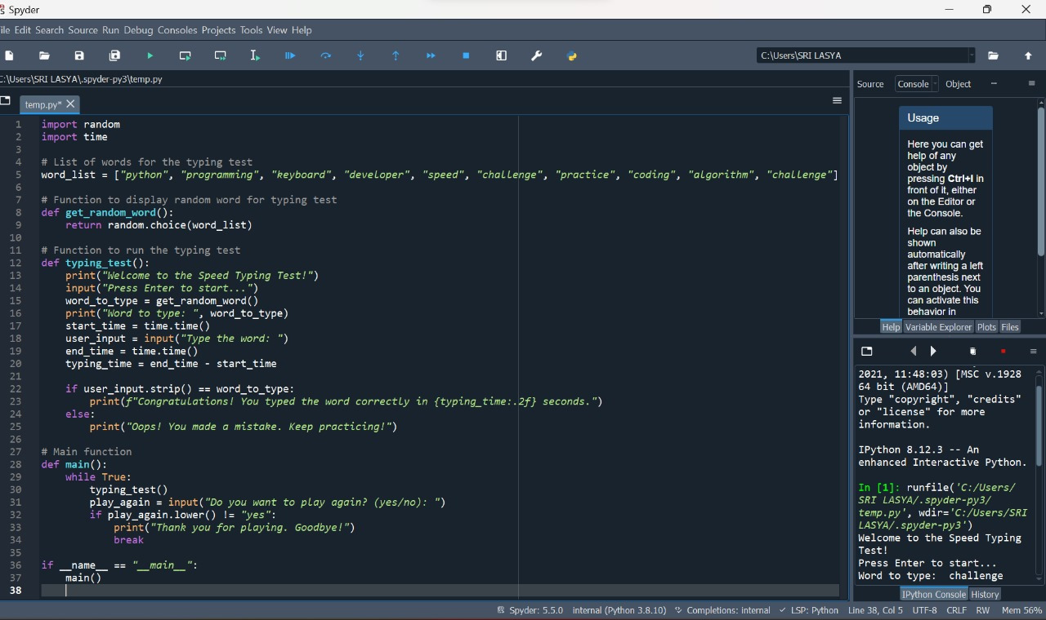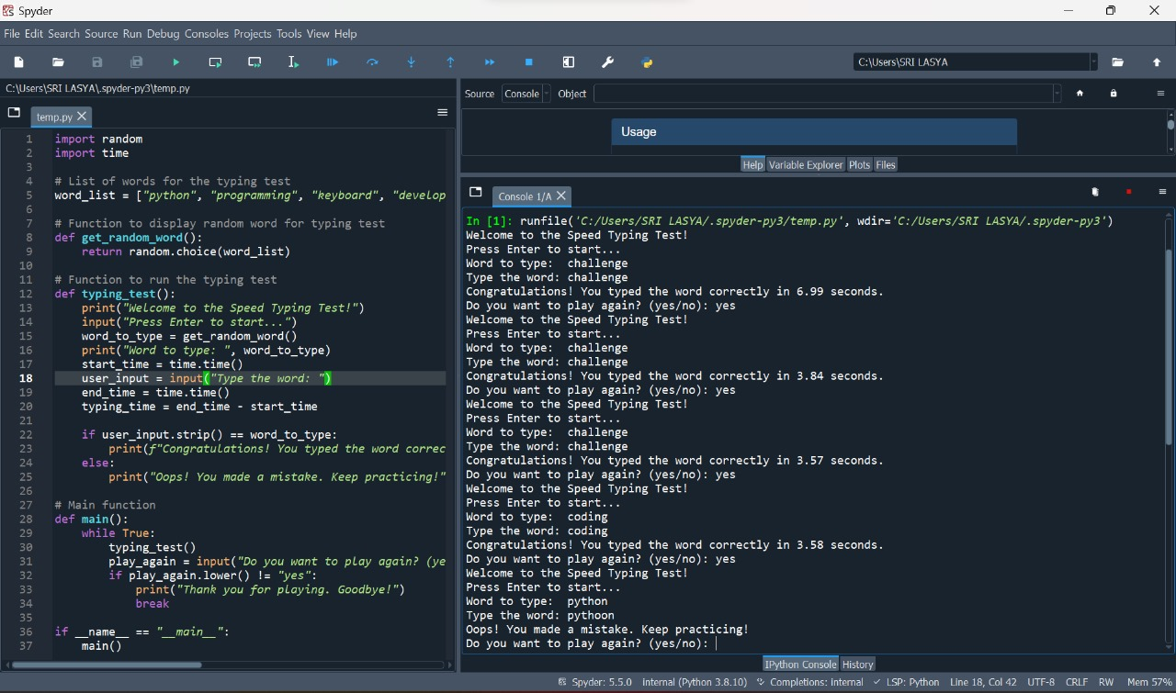

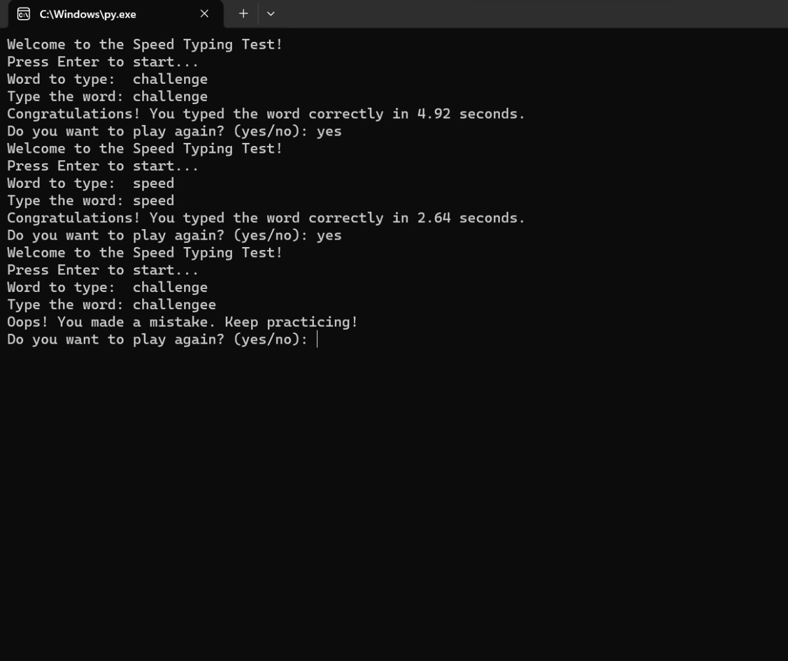

The conclusion of a speed typing test typically summarizes the key findings and performance of the participant. It may include metrics such as words per minute (WPM), accuracy, and any notable observations. The conclusion often addresses the individual's typing proficiency, highlighting strengths and areas for improvement. Additionally, recommendations for practice or further skill development may be provided. The goal is to offer a comprehensive overview of the participant's typing abilities based on the test results.